**Pls analysis user manual**

**Functions and what they do.**

**Commands.AddUser()**

Creates a user account with the input that give too it.

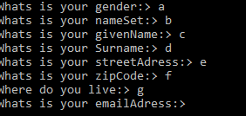

**Commands.AddBook()**

Creates a book and saves it.

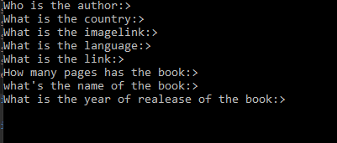

**Commands.BookReturn()**

If a book is lend away you can return it so that other can get it again.s



**Commands.BookLend()**

Gives a book away and puts it as not available for others.



**Commands.SearchBook()**

Looks of the book with the given input.

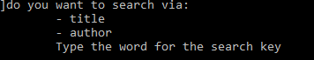

**Backup.BackUp()**

Creates a backup from all the save files.

**Backup.retrieve_BackUp()**

Uses the saved back up as.

**Book.ImportFromDB()**

It sets the books set in book database.